Group A [10x1=10]
1.Tick the correct answer .
a.Rs 6 is equal to __________paisa.
i.60paisa ii.600paisa iii.6000paisa
b.800paisa is equal to Rs_______________.
i.Rs8 ii.Rs80 iii.Rs800
c.1 cm is equal to_____________ mm.
i.100 mm ii.10mm iii.1mm
d.1m is equal to______________ cm.
i.1000cm ii.100cm iii.10cm
e.30kg is equal to____________ gm.
i.300 gm ii.3000gm iii.30000gm
f.What comes after 5490?
i.5491 ii.5492 iii.5489
g.50,000gm is equal to __________kg.
i.50kg ii.5kg iii.500kg
h.How many zeroes are there in ten thousand?
i.2 ii.3 iii.4
i.The Roman numeral of 65 is __________.
i.XLV ii.LV iii.LXV
j.How many minutes are there in 2 hours?
i.60 min ii.3600 min iii.120 min

Group “B” [12x2=24]
2.Arrange the data in ascending order.
6954 9540 2205 7660
_________ __________ ___________ ____________
3.Add the following
2 5 6 7 3 0 7 5
9 9 9 9 6 6 7 8

4.Subtract the following
5 0 9 4 2 3 8 4
2 5 6 6 1 9 9 9

5.Fill in the blanks with <,>and=.
11,332 ________8,956 24,600 ________24,600
2,231 _________7,766 4,509 _________4,550
6.Draw the line segments of the given measurements.
PQ= 5 cm

EF= 12 cm


7.Write down the length of the following.

cm
cm
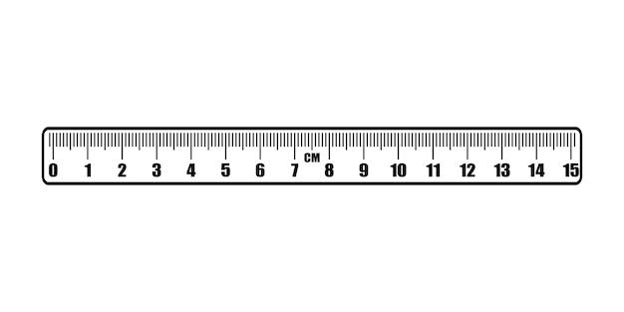

8. Name the greater angle.
G
D
P
S

H
I
F
E
R
Q
U
T

9. Write the names of arms of the following.
D
U
T
S
F
E

Arms=______and______ Arms=_______and_______

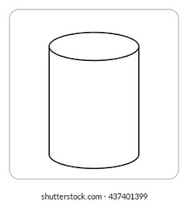
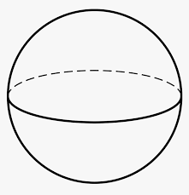
10. Identify the shapes of the following.

11. Subtract the following.
Rs Paisa Rs Paisa
8 0 6 4 8 6 2 4
4 0 2 6 4 0 1 2

12. Fill in the blanks.
[ 1km= 1000 m ]
- 5 km is equal to _______________m.
- 10 km is equal to _______________m.

13. Solve it.
a.There are two types of rice. The weight of Pokhreli rice is 12 kg 350gm
and that of the Basmati rice is 15kg 400gm.What is the total weight of both types of rice?

Group C[ 4x4=16]
14. Multiply the following.
 |  | 4 | 6
 | x | 6 | 5
 |  | 2 | 7
 | x | 7 | 3

15.Change into kilograms. [1kg = 1000gm]
a.15,000gm b.19,500gm
1000 ) 15,000 (

16. Convert into metres.
[ 1km=1000m ]
- 16km b. 3 km 50m

17. Add the following.
Rs Paisa Rs Paisa
4 8 8 2 1 1 0 8 9
9 6 2 5 1 2 0 9 5
+ 1 -100

